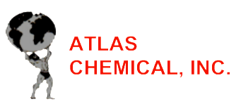
Safety Data Sheet
Section 1: Identification
Product: A-CHLOR
Proper name: Sodium Hypochlorite 12.5%
Cas No: 320222-06
Recommended use: Bleaching agent, Detergent, Cleaning agent.

Company details: Atlas Chemical, Inc.
P.O. Box 87250
Houston, TX 77287-7250
PH: 713-947-6400
Email: atlas.chem@live.com

Emergency details: ChemTel
Ph: 1-800-255-3924 or 1-813-248-0585
Contract number: MIS9947076

Section 2: Hazard(s) Identification
Physical Hazards: Not Classified (Non-Hazardous)
Health Hazards: Category 3
Flammability: Category 0
Reactivity: Category 1
Hazards Statement: May intensify fire, oxidizer. May be corrosive to metals. Causes server skin burn and eye damage. Very toxic to aquatic life.
Label Elements:
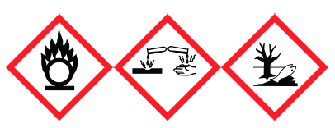

Section 3: Composition/Information on Ingredients
Chemical Name | Cas No. | %
Sodium Hypochlorite | 7681-52-9 | 11.9-< 15.6
Sodium Hydroxide | 1310-73-2 | 0.1-< 2
Other components |  | 86.5

Section 4: First-aid Measures
Inhalation: Move to fresh air and get medical attention.
Skin Contact: If on clothes rinse immediately contaminated clothing and skin with plenty of water before removing clothes. Rinse skin with water/shower. Call a physician or poison control center immediately.
Eye Contact: Flush with running water for 15 minutes and consult with physician.
Swallowing: Call a physician or poison control center immediately. Rinse mouth. Do not induce vomiting.
General Information: Take off all contaminated clothing immediately. Contact with combustible material may cause fire. Ensure that medical personal are aware of the material(s) involved, and take precautions to protect themselves. Wash contaminated clothing before reuse.

Section 5: Fire-Fighting Measures
Fire-fighting equipment/instructions: Self-contained breathing apparatus and full protective clothing must be worn in case of fire.
Suitable Extinguishing: Foam, powder and carbon dioxide (CO2).
Unsuitable Extinguishing Media: Do not use water jet as an extinguisher, as this will spread the fire.
Specific Hazards: Greatly increases the burning rate of combustible materials. Containers may explode when heated. During fire, gases hazardous to health may be formed.

Section 6: Accidental Release Measures
Spill and leak precautions: Small spill absorb with sand or other non-combustible material and transfer to containers for later disposal. Clean surface thoroughly to remove residual contamination.
Large spill stop the flow of material, if this is without risk. Dike the spilled material. Absorb with sand or other non-combustible material and transfer to containers for later disposal.
Environmental precautions: Avoid release to the environment. Prevent further leakage or spill if safe to do so.
Waste disposal: Dispose of contents/container in accordance with local/regional/national/international regulations.

Section 7: Handling and Storage
Safe Storage: Store locked up. Keep away from heat. Store in cool, dry place out of direct sunlight. Store in corrosive resistant container with resistant inner liner. Store in tightly closed container. Store in a well-ventilated place. Do not store near combustible materials.

Section 8: Exposure Controls/Personal Protection
General protection: It is recommended that users of this product perform a risk assessment to determine the appropriate PPE.
Eye protection: Wear safety glasses or Goggles and face shield.
Skin protection: Wear appropriate chemical resistant gloves.
Other: Wear appropriate chemical resistant clothes.

Section 9: Physical and Chemical Properties
Appearance: Liquid.
Appearance and color: Clear to pale yellow.
Boiling point: >110°c
Melting point: -20 – 16.11°c
Flash point: N/A
Flammable limits: N/A
Vapor pressure: 12 mm Hg @20°c
Specific gravity: 1.209 @ 20°c
Solubility in water: Soluble
PH: 12-14

Section 10: Stability and Reactivity
Chemical stability: Material is stable under normal conditions.
Reactivity: Greatly increases the burning rate of combustible materials. Reacts violently with strong acids.
This product may react with oxidizing agents. May be corrosive to metals.
Hazardous Polymerization: None.
Hazardous decomposition: Chlorine and Hydrogen Chloride.
Conditions to avoid: Heat. Do not mix with other chemicals.

Section 11: Toxicological Information
Inhalation: Irritation to respiratory system.
Skin contact: Severe burns.
Eye contact: Serious eye damage.
Ingestion: Digestive tract burns.

Section 12: Ecological Information
Ecotoxicity: Very toxic to aquatic life with long lasting effects.

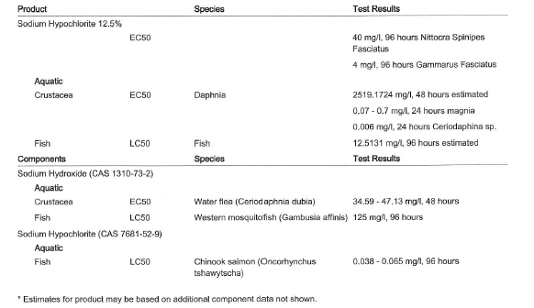

Section 13: Disposal Considerations
Disposal instructions: Collect and reclaim or dispose in sealed containers at licensed waste disposal site. Do not allow this material to drain into sewers/water supplies. Do not contaminate ponds, waterways or ditiches with chemical or used container. Dispose of contents/container in accordance with local/regional/national/international regulations.
Hazardous waste code: D002: Waste Corrosive material (PH-<=2 or >12.5, or corrosive to steel).
The waste code should be assigned in discussion between the user, the producer and the waste disposal company.
Waste from residues/unused products: Dispose of in accordance with local regualations. Empty containers or liners may retain some product residues. This material and its container must be disposed of in a safe manner.
Contaminated packaging: Since emptied containers may retain product residue, follow label warnings even after container is emptied. Empty containers should be taken to an approved waste handling site for recycling or disposal.

Section 14: Transport Information
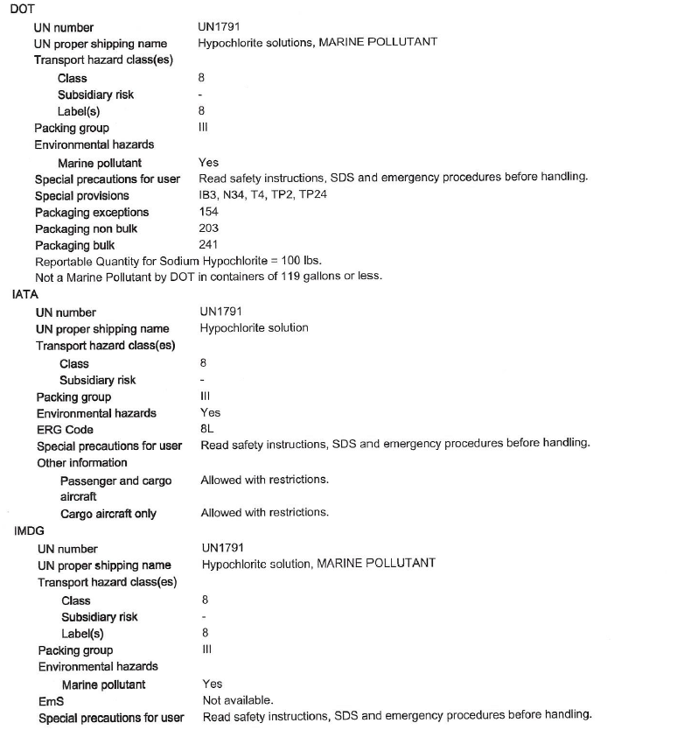
DOT/IATA/IMDG: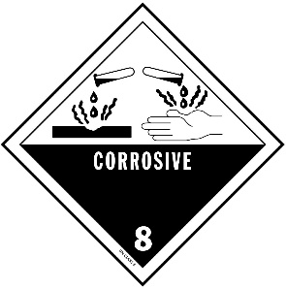 Marine Pollent: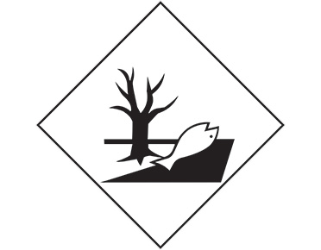

Section 15: Regulatory Information
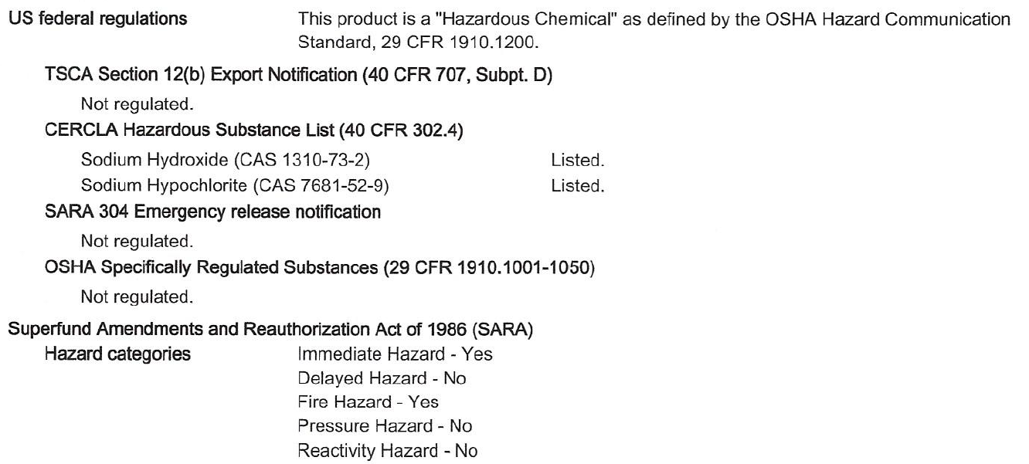
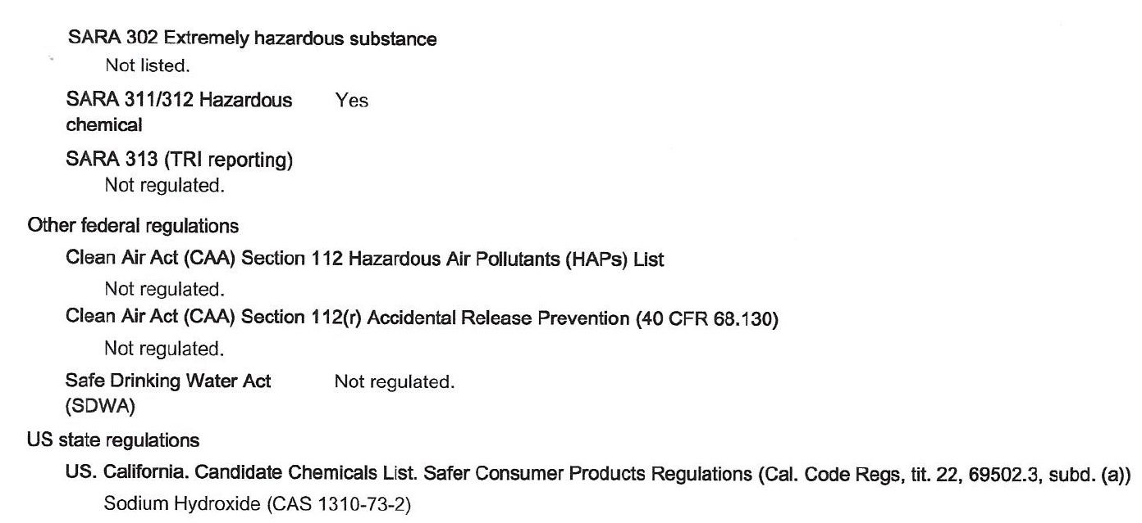
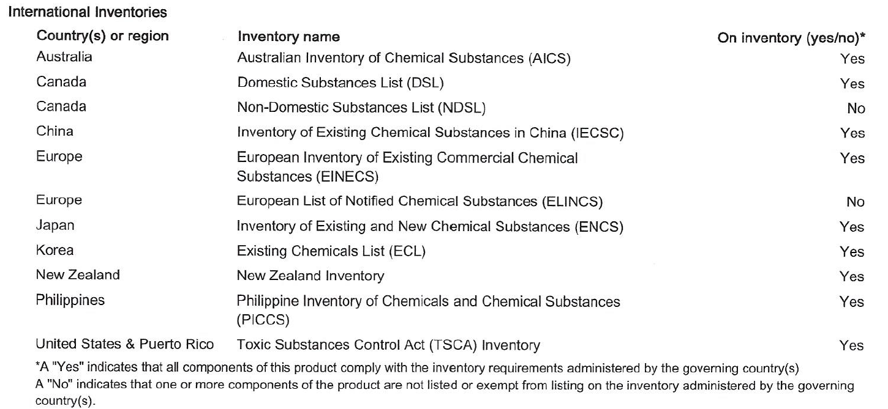
Section 16: Other Information
Issue date: 07/10/2020
Revision: 07/10/2020
Version: 3
Disclaimer: This information provided in this Safety Data Sheet has been obtained from sources believed to be reliable. Atlas Chemical, Inc. provides no warranties, either expressed or implied and assumes no responsibility for the accuracy or completeness of the data contained herein. This information is offered for your information, consideration, and investigation. Ingredient listed in TSCA Inventory.

